Basic Functions of Video Editing
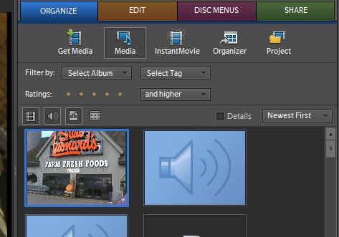
Get Media / Media
This area of your toolbox will help you get your needed media for your project (video, pictures, music, narrations, sound effects). If you are uploading or importing NEW media, go to Get Media. If you are just looking for media you already imported, then it should appear in the Media section.
Cutting a Video or Audio Clip to Move or Delete
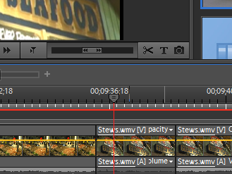
If you want to add your voice/narration over your video, you can do this by plugging in a microphone and going to Audio Tools near the top of your timeline. Click on that pull-down menu and select Add Narration. Follow the on screen directions to click Record and then Stop. Once you click Stop, the narration is adding to your timeline in the Narration section.
Adding Narration
You will want to cut out and delete many clips in your video. You may also wish to move a clip. You can even cut out a piece of a song or narration. You do this with the cutting tool (scissors). Cut the beginning AND the end of the clip you do not want. Then either delete it with the delete key or move it where you want to by dragging it.

