Converting Music to WAV Files

Once you have your music file saved to your computer, you may then use
ONLINE-CONVERT.COM to help you convert it to a usable file for editing.
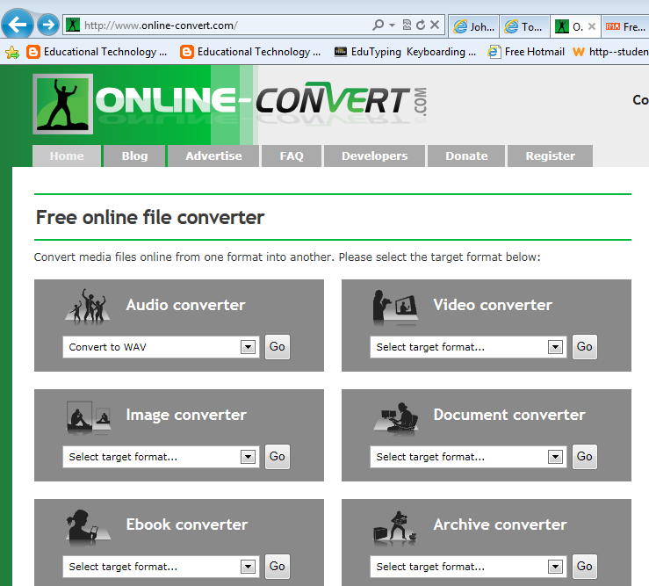

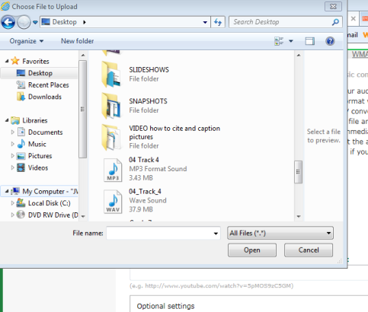
Click on your music file to upload
- Click on the pull down menu and select CONVERT TO WAV
- Click Go
- Scroll down to the UPLOAD YOUR AUDIO section and browse to find your music file that you saved.
Click on the Audio Converter

- Once you find your music file, click on the file and click OPEN.
- Click on CONVERT FILE
- Once process is complete, a yellow box will appear at the bottom of your screen.
- You MUST click on the pulldown menu next to Save and click SAVE AS.
- Save your new converted file to your folder in the proper drive.
- Give the file a good name if it doesn’t have one.

