When you want to make a listing of information neat and easy to read in your writing piece, you can create a table.

STEPS:

- Go to the Table pull-down menu and selecting Insert to Table to Insert Table
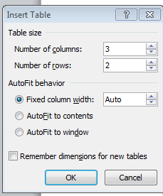

- Choose your number of rows and columns.

Joe | Smith | Cat
Tina | Jones | Hamster
- Input your data

- Put your cursor in the top row and create another row for your HEADINGS.
Do this by right clicking on the row and Inserting a Row. Add headings to describe what is in each column. BOLD your headings.

First Name | Last Name | Favorite Animal
Joe | Smith | Cat
Tina | Jones | Hamster

- Right click on top row and create another row for your table’s title.
- Then highlight the whole new row and right click and MERGE cells.

First Name | Last Name | Favorite Animal
Joe | Smith | Cat
Tina | Jones | Hamster

- Type in your title.

Favorite Animals of Friends
First Name | Last Name | Favorite Animal
Joe | Smith | Cat
Tina | Jones | Hamster

