Directions for creating a data table and graph in Excel
- Create a two column data table (using categorical and numerical data). Put data in columns (each piece of data gets its own cell!) and please use headings for each column.
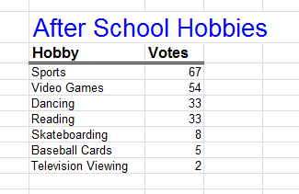
Headings
Data
Title
- Select your data (ONLY the data) with your cursor and then go to INSERT and choose a graph/chart to create.
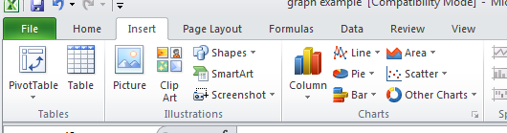

Choose a graph

- Once you have graph on your sheet, you MUST add titles for axes, title, data labels if needed, and change colors. You must also DECIDE if a legend is needed.
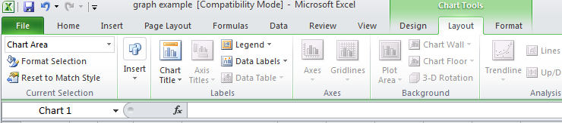
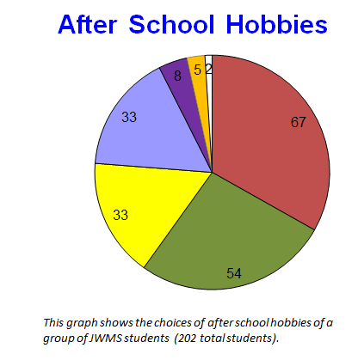
Charts Tools is where you will find all the items you need to finalize your graph

