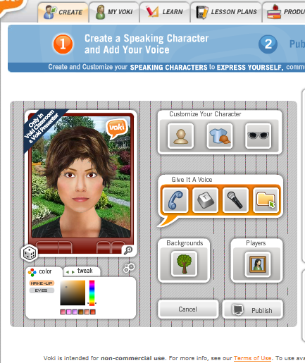**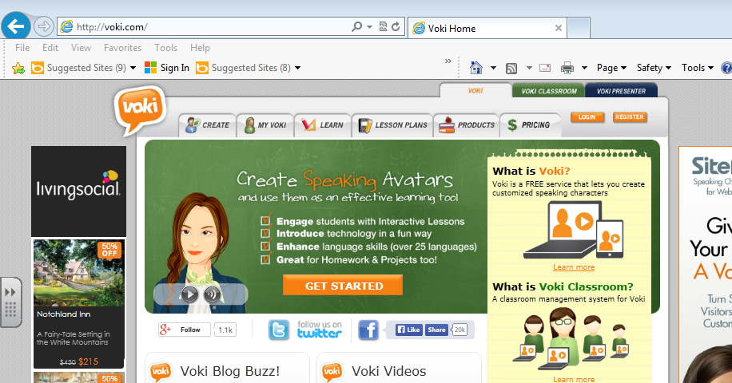Making an interactive avatar for my presentation**

**Dress** it up and give it bling!

Publish when done. You can now take a link to include in email, social media, or a presentation or **use embed code to place directly onto your website.**

**Change hair color, eye color, skin, and size** of your voki here!

Choose a **background** for your voki. You can move your figure around the background too.

Use a mic or type in text to **create a voice** for your voki

**Pick a character/head.** You cannot choose the Voki Classroom ones because we do not have a class account.

Click the CREATE tab