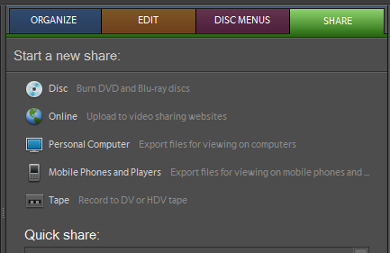
Saving Video As An MPG
- Select SHARE
to Personal Computer

- Click MPEG
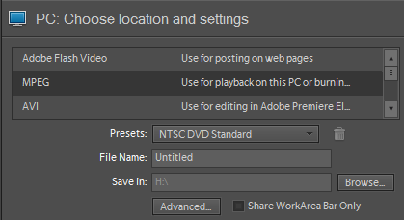

- Name the video
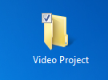
- Browse to your Video Project Folder.
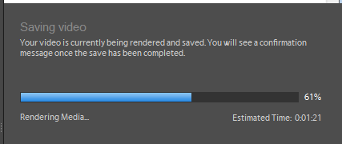
- Open that folder and then click Save.
Your video will be rendered and saved.
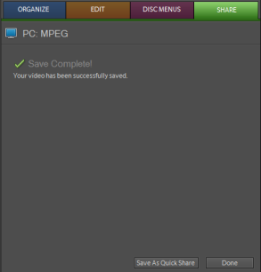
- When completed, click Done

- Open your Video Folder and click on the MPG file. Your video should begin as a movie, not as a project. If it doesn’t, please see me.

- Lastly, you will need to upload your video to your website. This may mean you need YouTube. Your mpg saved on a flash drive may be needed if you are using my account. See me with questions!

