Using Clipart

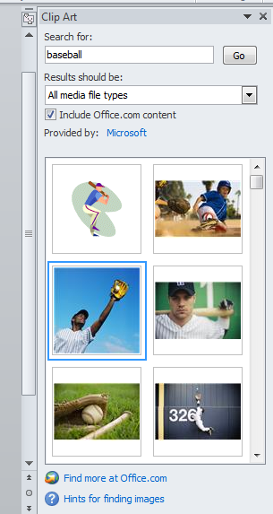
- Go to the INSERT ribbon and click on CLIPART
- In the CLIPART menu, search for a topic you are looking for. You may need to try different words
- Click GO and select the clipart you desire.

- Resize your clipart image using the corner circles only.

- Use the Green Rotator Tool if you want to rotate your image.

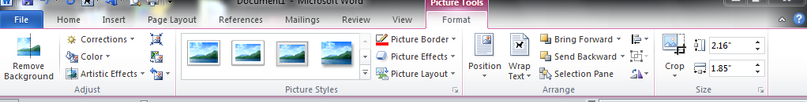
- Once you click on your clipart image, you have access to the Picture Tools menu where you can then use the many tools to edit your image (Crop, Layer, Choose Borders, Remove Backgrounds, Add effects)

